Project Report

Government Collage of Engineering, Jalgaon

 (An Autonomous Institute of Maharashtra)

Project Topic:

Online Collage Classroom

**Submitted to: Submitted By:**

**Prof. Mr. Vinit Kakade Vaibhav Sontakke**

**(Subject RDBMS) PRN:1942207**

**Shubham Yadav**

**PRN:1841059**

INTRODUCTION

Online College Classroom is a web based notes and assignments sharing and management system which helps students and teachers to share their notes online effectively. It reduces the wasting of time in manually distributing notes to each individual. It greatly overcomes the lack of availability and converts the manual old school paperwork to a fully automated and managed online system.

College Classroom allows it's users to securely register and log in to their individual accounts and create, read, update, delete notes according to their needs. It provides notes to everyone in a very secure manner.

OBJECTIVE

The objectives of the system are-

* To reduce manual paperwork.
* Reduced sharing and distribution time.
* Increased reliability.
* Increased operational efficiency.
* Data security

This Classroom Management System can be readily used by non-programming personal avoiding

Human handled chance of error. This project is used by Three types of users

1. Students.

2. Teachers

3. Administrators

Students and Teachers can create their accounts and start viewing notes shared by other users as

well as upload their own notes.

Administrator is must be an authorized user who will keep track of all the uploaded notes and

manage users as well through the admin panel.

**SCOPE**

project has a large scope as it has the following features which help in making it easy to use,

understand and modify it:

* Ease of sharing notes
* No Need to do Paper Work.
* To save the environment by using paper free work.
* To increase the efficiency of the notes.
* Management of all notes.
* Easy and secure user log in and registration.
* Easy password recovery through email.
* Department based notes management.

Main Points are:

* Simplified Management of all notes.
* Upload of notes and Assignments
* Approve and disapprove notes features.
* Admin Panel.
* User profile management.

**TOOLS AND TECHNOLOGY USED**

**Tools:**

**LAMP**: LAMP is an archetypal model of web service stacks, named as an acronym of the names of its original four open-source components: the Linux Operating System, the Apache

HTTP Server, the MYSQL relational database management (RDBMS), and the PHP.

**PhpMyAdmin** : PhpMyAdmin is a free and open source administration tool for MYSQL

**Technology:**

**1. PHP**: - PHP (recursive acronym for PHP: Hypertext Preprocessor) is a widely-used open source general-purpose scripting language that is especially suited for web development and can be embedded into HTML.

**2 SQL:** - SQL is a structured query language used for querying database.

**3.HTML:** - It is used for giving eye catching look to the website. And also providing easy to use GUI.

**4.CSS:** - CSS is cascading style sheet which is used to give designer look to HTML using the external file.

**5.Java script:** - Java script is used for client side scripting which can help in using validation on the website and many more other functions.

|  |  |
| --- | --- |
| Sr. No | Description |
| 1.1. | Homepage |
| 1.2. | User login |
| 1.3. | Signup |
| 1.4. | Upload |
| 1.5. | User Dashboard |
| 1.6. | Admin Login |
| 1.7. | Admin Dashboard |
| 1.8. | Logout |
| 1.9. | Screenshots |
| 2.0 | Reference |

INDEX

* 1. **Homepage:**

The classroom homepages is a basic User Interface between user and classroom. This page can be attract towards the classroom page. This home consider three pages

* Login
* Signup
* upload

**1.2. User login:**

Each teacher and Students in the college is assigned a unique username and password Created During signup pages. The username is their teacher ID or Students ID and the same for password.

**1.3. Signup:**

The signup page are used for Creating User ID and password, and also fill the required details form registration users for Classroom.

**1.4. Upload**

Here the user can be upload the assignments and notes after the completion of registration

The file can be pdf, docs, txt etc.

**1.5. User Dashboard.**

The user dashboard are mainly displaying the submissions of user their assignments and notes or work that they can be uploaded

The user Dashboard consist two fields:

* Uploading: For uploading there assignments.
* Profile: The profile view are displaying user details and Edits

**1.6. Admin login:**

The admin having unique username and password that assign by system . The admin can login by there id and password

**1.6 Admin Dashboard**

The administrator is responsible for adding and maintaining all the departments, students, teachers, classes and courses. All this data is stored in the database in their respective tables. The admin is also responsible for adding and maintaining the list of teachers assigned and records

The admin can be View, downloads or delete and approved the works and manages all the things.

**1.7 Logout:**

The user can be logout the system after completion their work by clicking Logout Button.

**1.9. Screenshots:**

**1.Homepage**



**2.Login Page**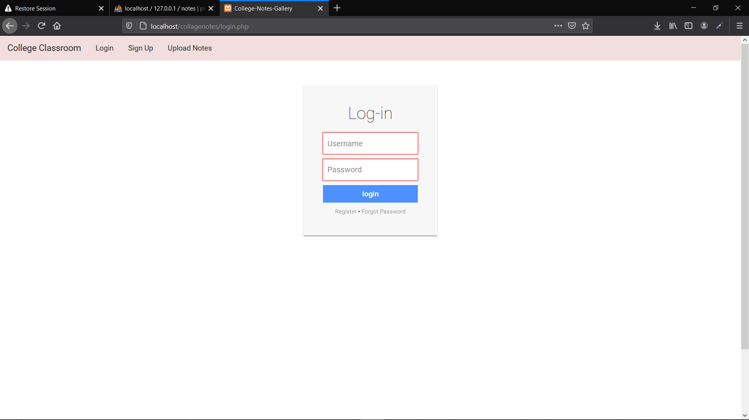

**3.Signup page**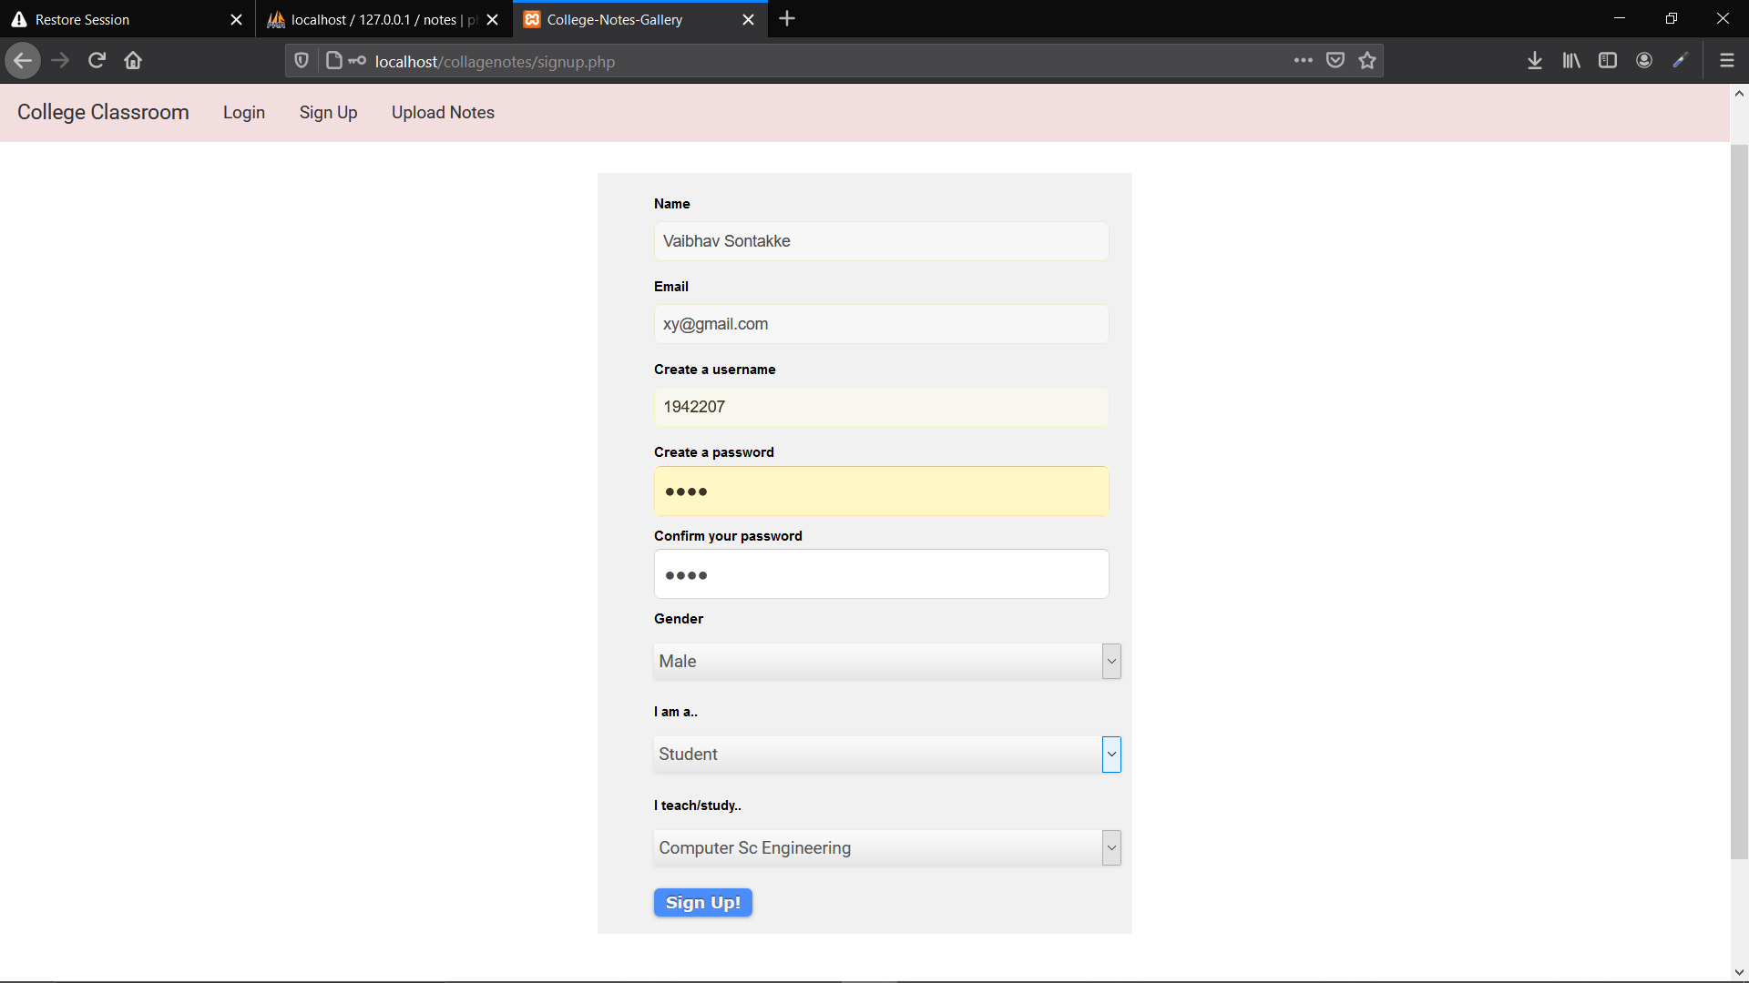

**4.User login successfully.**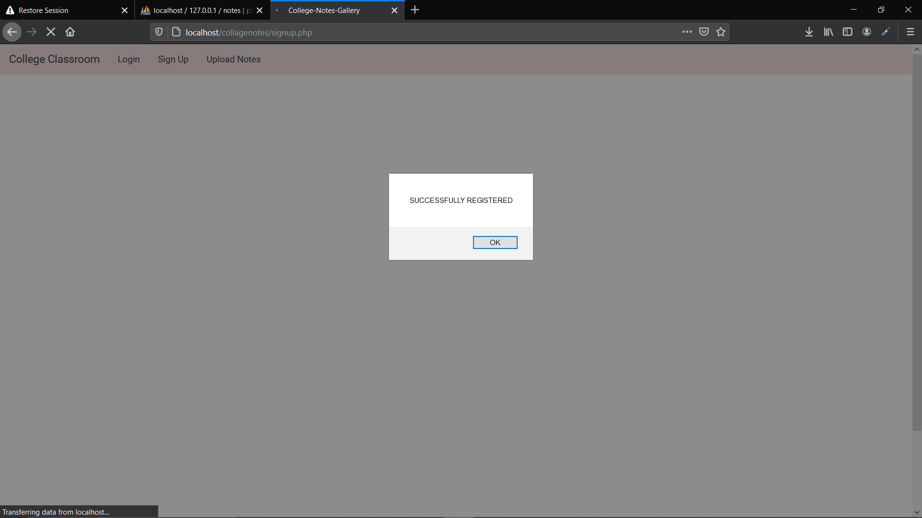

**5.User Dashboard**

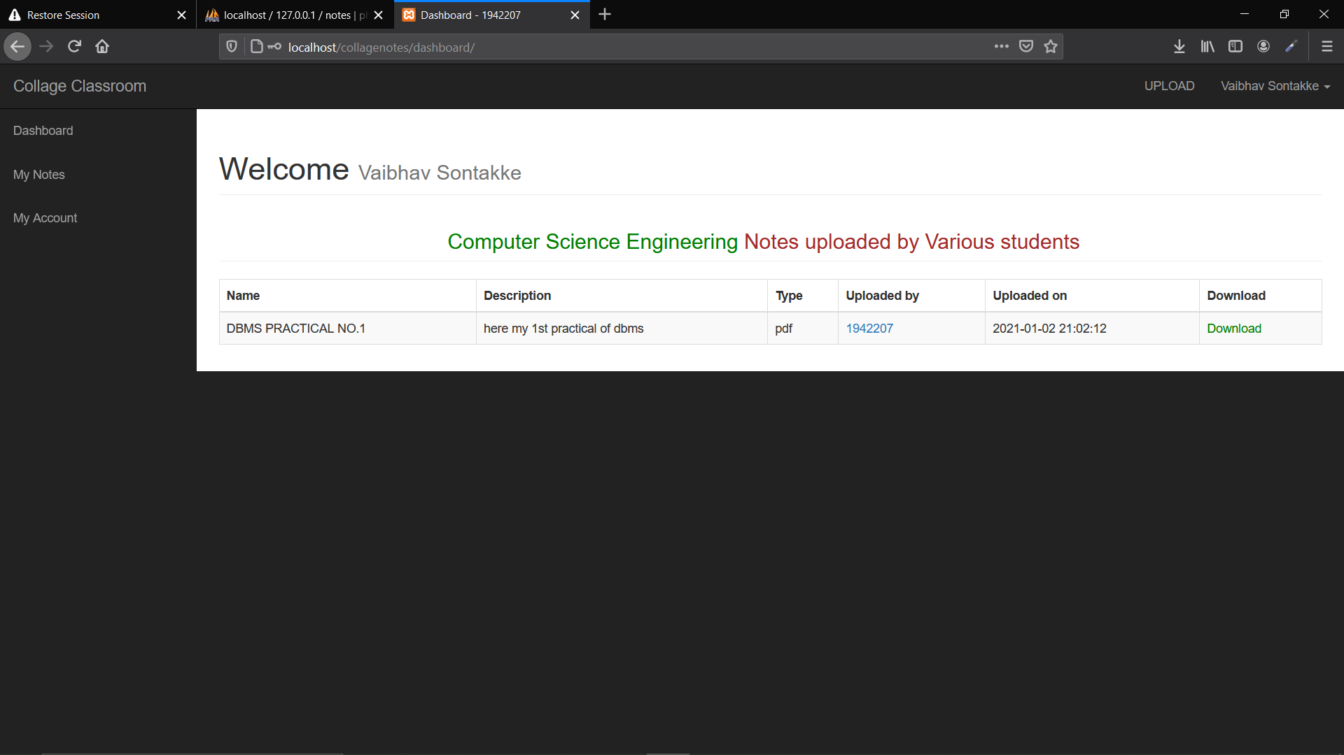

**6.User updating notes or assignments**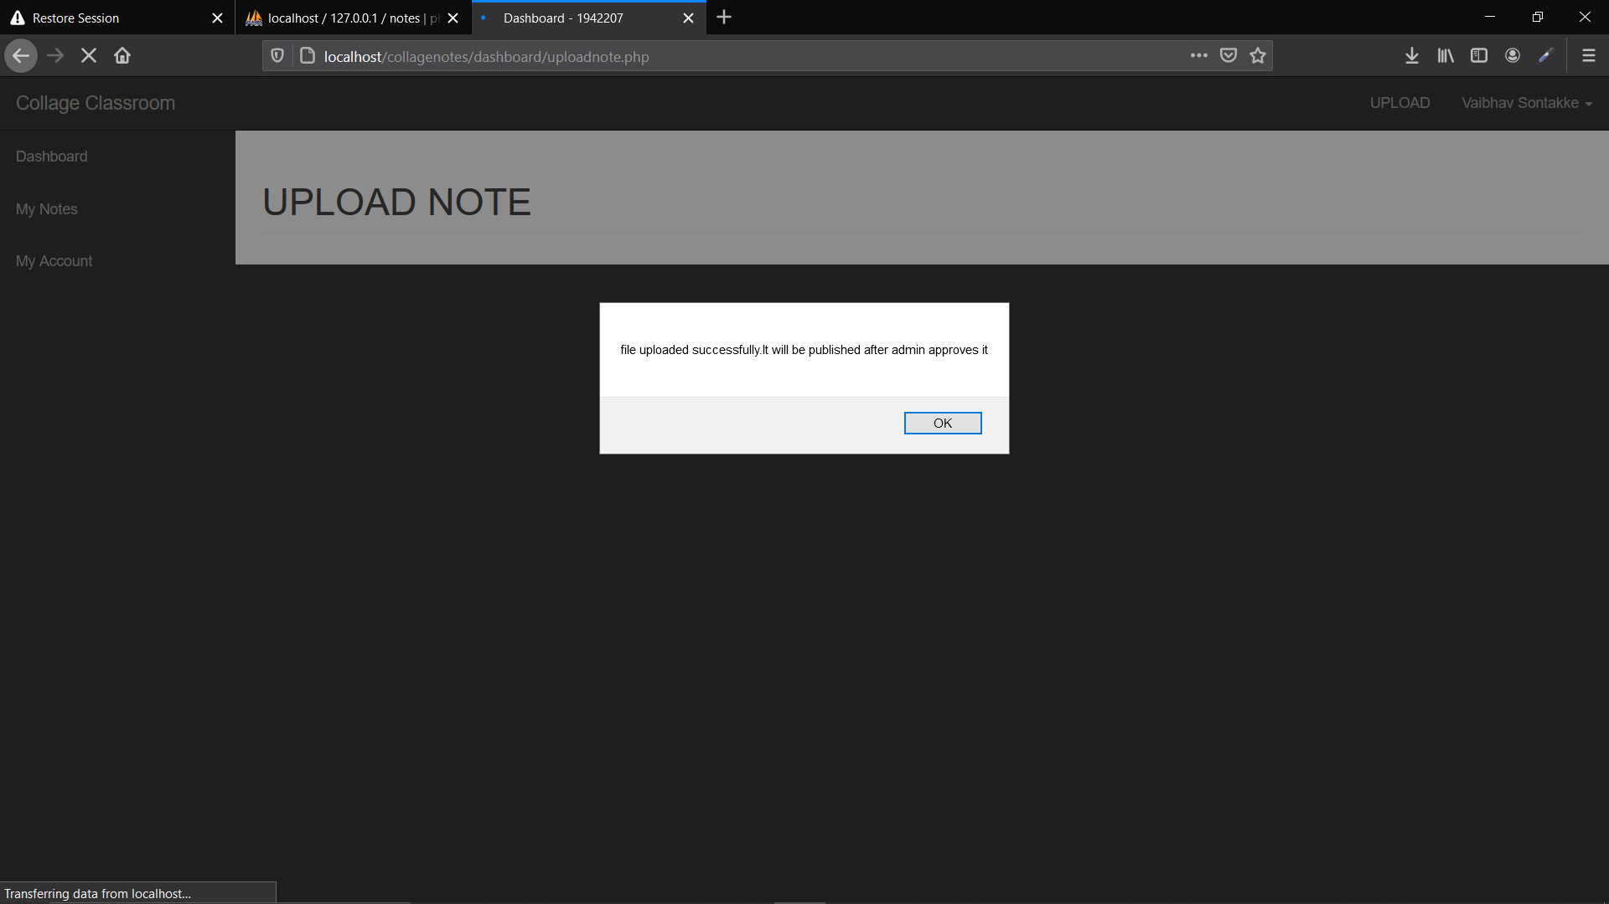

**7.Students Data or work files**

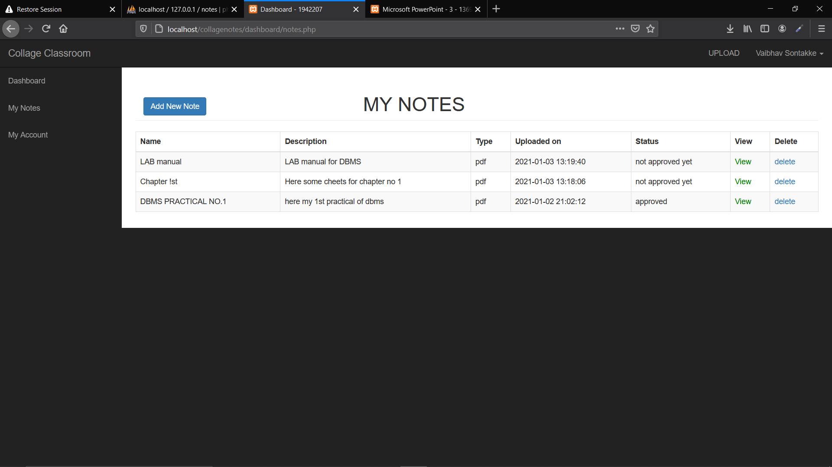

**8.View Pdf files**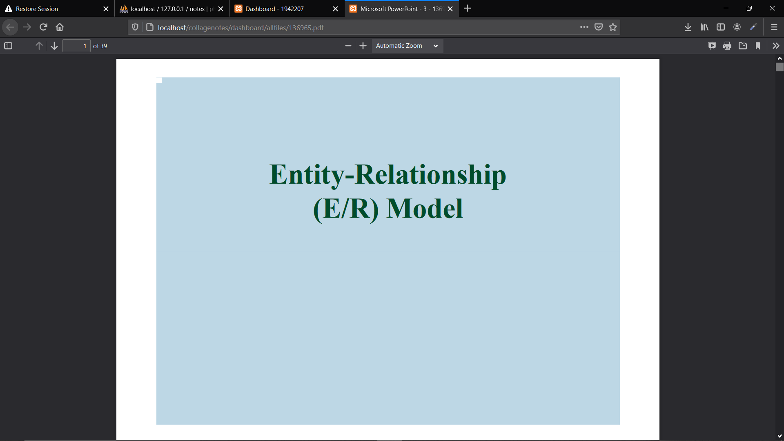

**9.View Profile**

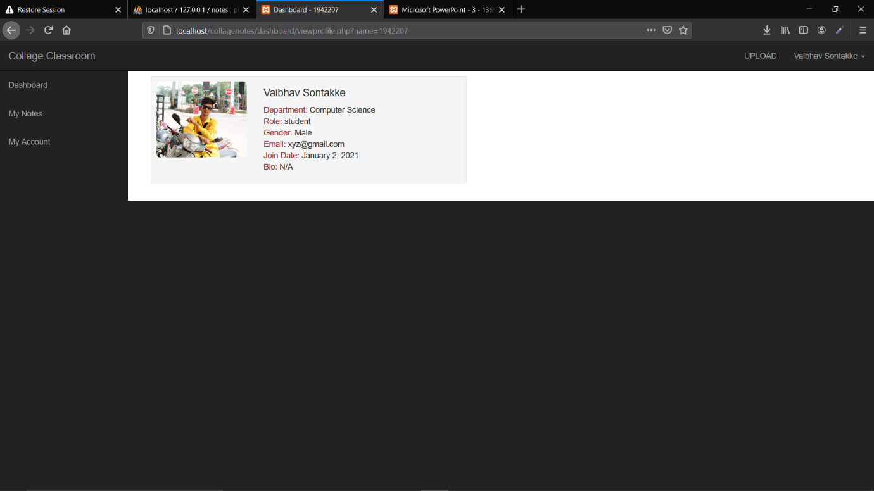 **10. Editing profiles** 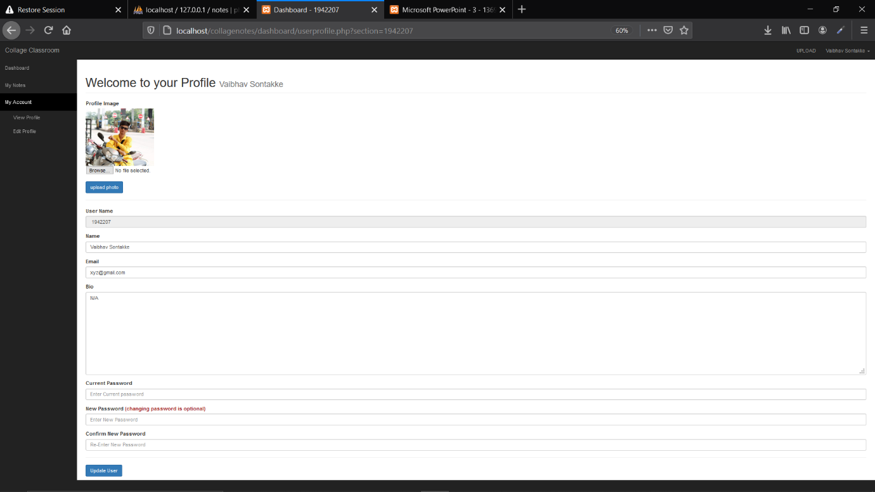

**11.Admin Pannel Database.**

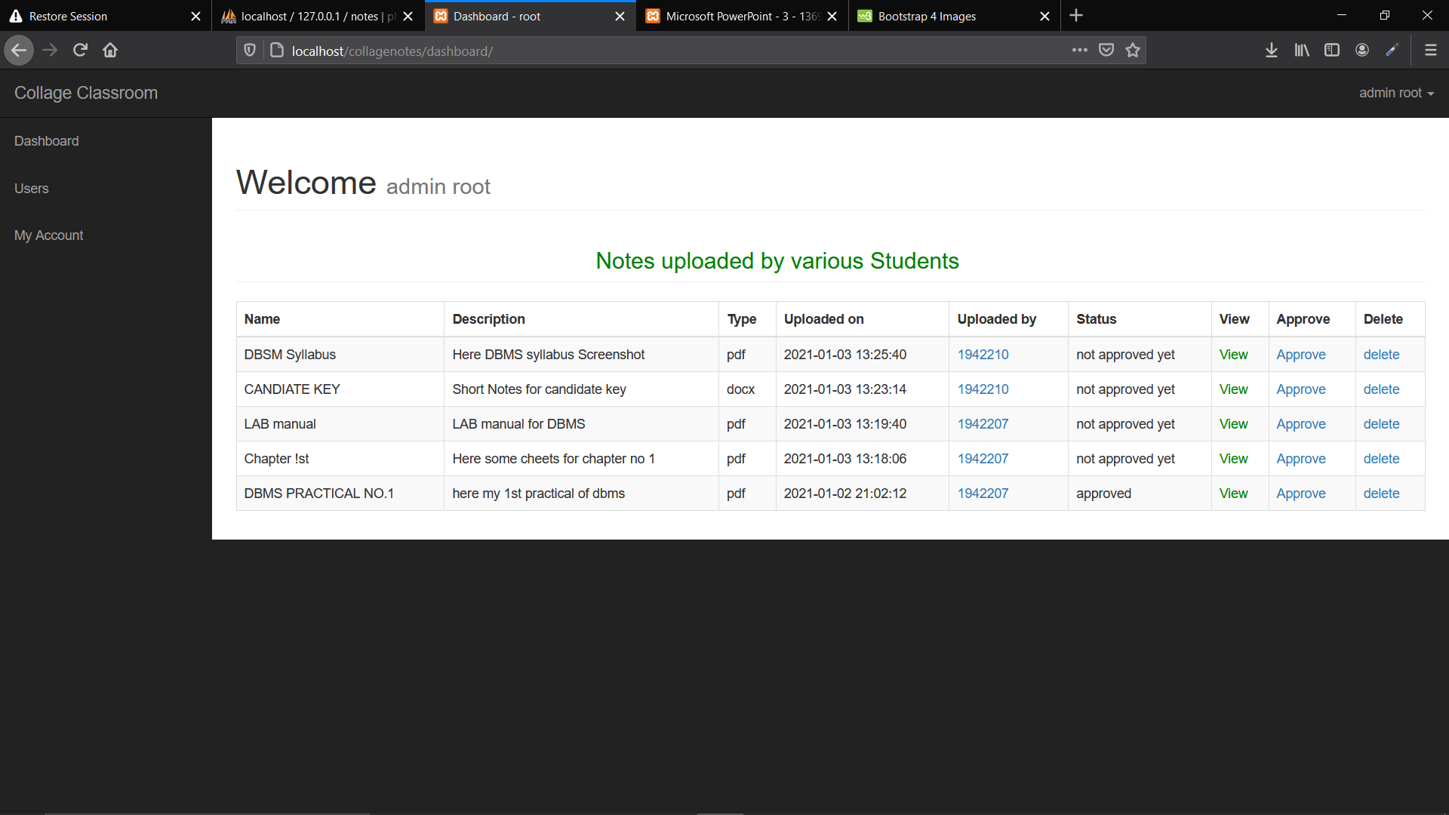

**12.Admin Profile**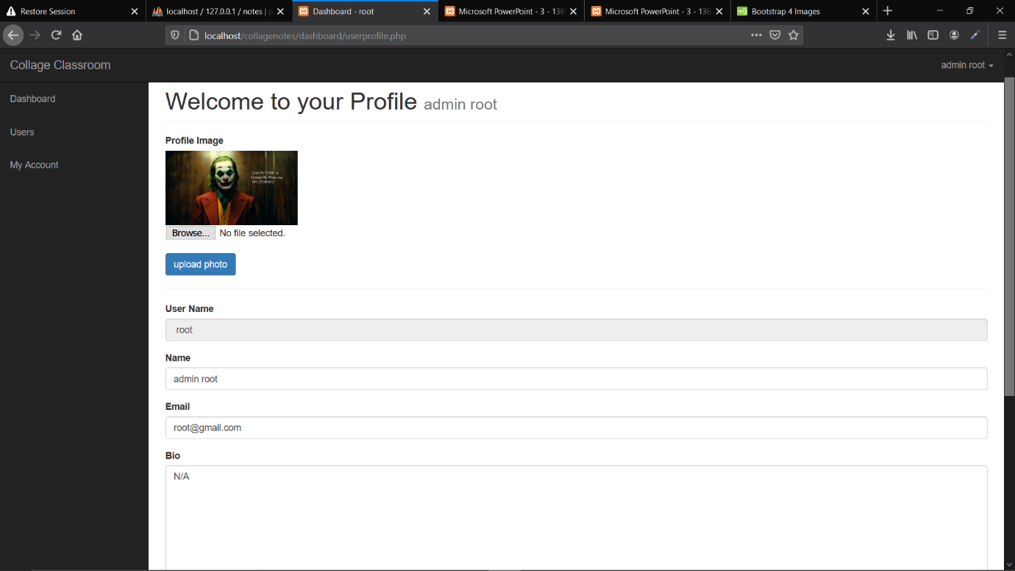

**2.References**

1. Elmasri and Navathe: Fundamentals of Database Systems, 7th Edition, Pearson

Education, 2016.2.www.stackoverflow.com

3.www.w3school.com